**QuickSeries Test**

1. User Stories for the Feedback Module:
   1. **“Categories” screen**

|  |  |
| --- | --- |
| QUK-001: Display the “Feedback”, “Questions” and “Report bug” in the “Categories” screen | |
| As a: | Satisfied/Intrigued customer |
| I want to: | Know quickly where to give feedback/ask questions |
| So that: | I don’t have to navigate indefinitely in the application to give feedback or get some of my questions answered |
|  |  |
| A.C.: | * The page should be divided in two sections (See image in attachment);  1. Upper section being the “Get in touch!”; 2. Lower section being the “Having a Technical Problem?”;  * “Get in touch” & “Having a Technical Problem?” must stay title of those sections; * Top section (Get in Touch) should displayed the Feedback sub-menu and the Questions sub menu as the lower section (Having a Technical Problem) should just include the Report a bug; * Remove the number of items included in the folder (displayed actually);   *NTH (Nice to Have):* Integrate Icons (To validate with PO) instead of the folders. |
|  |  |
| Epic Link: | UI/UX |
| Points: | *TBD in team* |

Attachment(s):

* 1. **Having a technical problem screen**

|  |  |
| --- | --- |
| QUK-002 Have access to the “Report Bug”, “Questions” or “Feedback” directly | |
| As a: | Regular Customer |
| I want to: | Access quickly the page of Questions/Feedback/Bug |
| So that: | I don’t waste time on |
|  |  |
| A.C.: | NOTE: To complete that story, QUK-001 must have been done previously.   * On the “Categories” screen, hyperlinks for “Get in Touch” & “Having a Technical Problem?” should be removed and therefore not effective; * You are redirected automatically to the sub-section you click on: (1) By clicking “Questions”, you automatically get redirected to the Questions page; (2) By clicking “Feedback”, you automatically get redirected to the Feedback page;  1. By clicking on “Report a bug”, you automatically get redirected to the Report a bug page;  * *NOTE: This should make the middle pages obsolete. Therefore, the extra pages should be deleted;*   Child Story of: QUK-001 |
|  |  |
| Epic Link: | System effectiveness |
| Points: | *TBD in team* |

* 1. **Report a bug screen**

|  |  |
| --- | --- |
| QUK-003 Add Company information to the Contact information | |
| As a: | Administrator of the system |
| I want to: | Know what company is reporting problem |
| So that: | I can identify more easily the causes of that issue between customers |
|  |  |
| A.C.: | * In the report Bug screen, an extra attribute should be added in the personal customer information table in the database: (1) The attribute added should be the company; (2) It’s a select box from a code list; (3) The possible elements from the code list should be the following: *Empty*, NASA, FBI, Pepsi, Donald Trump Funny T-Shirts or Other. * That field is name : Company; (1) It should be displayed in the UI between the Name and the email (same display as these two attributes should be present); * This field should be mandatory; * An interrogation icon,” Help”, is added next to the name (1) By clicking on it, a pop-up opens; (2) The text in the pop-up is the following: “This information allows us to help you more efficiently. Be aware that this stays confidential information and that we’re not going to reveal to your company that you done a request.”   NTH: The last company saved in your profile should be put by default. |
|  |  |
| Epic Link: | Data Collection |
| Points: | *TBD in team* |

|  |  |
| --- | --- |
| QUK-004 Change upload parameters for support | |
| As a: | System |
| I want to: | Support more type and sizes of file |
| So that: | I can refuse less bug reports |
|  |  |
| A.C.: | * Raise the maximum size of documents attached to “Sceenshot” Selection from 5mb to 50mb; * Allow Jpg., Png., Svg (already possible to upload) **.ico and .pdf (to integrate)**. |
|  |  |
| Epic Link: | Document Handling |
| Points: | *TBD in team* |

|  |  |
| --- | --- |
| QUK-005 Pre-populate information base on your profile | |
| As a: | Regular Customer |
| I want to: | Have fields pre-populate when I report a bug |
| So that: | I don’t get overly frustrated typing information again |
|  |  |
| A.C.: | * Based on the profile of the individual, the following fields should already be pre-populated:  1. Contact information: Name, Company (If QUK-003 is done) & e-mail; 2. Technical Stuff: Device used, make and model & version.  * A blue (could be other color if the purpose is served) color should fulfilled the case in which information are pre-filled (see attachment for example); * Those information could all be change, it won’t change the profile section of the user however.   NTH: If a new information of the contact information is entered, a warning message should appear to remind you that the information provided doesn’t fit the profile. It will allow to pursue with the request or cancel (go back to the page to modify information). |
|  |  |
| Epic Link: | System effectiveness |
| Points: | *TBD in team* |

Attachment(s):

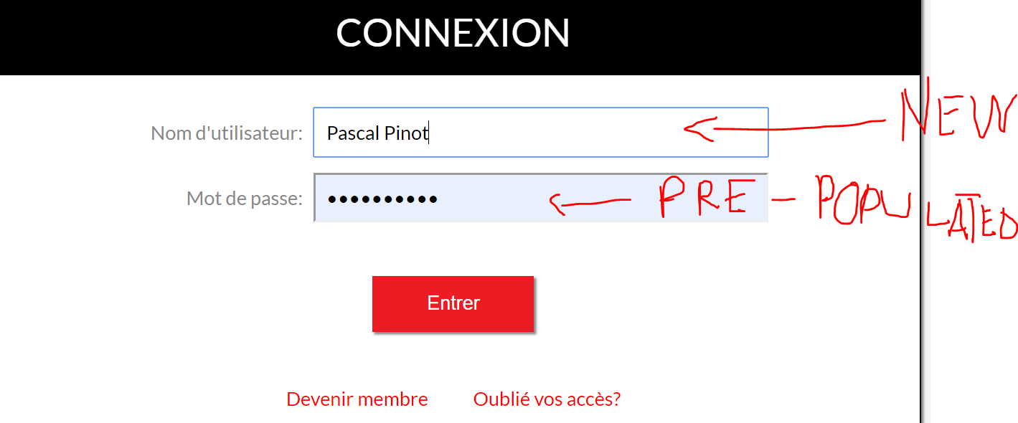

1. Release note for the end user:   
   *Note: Not sure if the admin is directly an end user. If he wasn’t, the following stories should be included on a release note for the clients/administrators only.  
   However, since there wouldn’t be any story otherwise in the releases note, I assume the admin could be an end user; I included them.*

Dear Clients of QuickSeries,

We’re delighted to inform you that we just released version 11.01 of our QuickSeries Publishing Platform. In the latest few weeks, the team have been working on a lot of great features and improvements to the software. You’ll found a summary bellow of what you could expect from this delivery:

**New Features and Improvements:**

* A completely new page has been developed to see the aggregate results of a selected assessment. This will allow you to get detailed information on the assessment such as the number on responses, the time they have been fulfilled and the average score.
* It also gives you details by question such as their number, if it was a right answer as well as a percentage of people who answered to each choice.
* A second page will allow you to select and after seeing the details of the individual that fulfilled the assessment if this one is configured to be shared. It will give high level information on the individual such as his name and e-mail, but also details on his number of responses timeline and score.
* This page will also allow you to see each question and the appropriate answer of the participant (if allowed).
* A third page have been developed to help you follow the trends of the assessment on a dedicated time period. This will give you details on which answered have been picked for which question historically, in percentage and graph.
* Also, you can have ability to analyze data based on “recent” or “custom” timeframe. Therefore, it’s now possible to configure the timeframe selected quickly between 24 hours, 7 days, 30 days or by any other configuration using the selection: “*Lifetime*”.
* News, promos and alerts that belongs to a module locked by an access code will NOT be sent trough notification anymore.
* Filters will persist from your manual settings.

**Fixes:**

* Informational pop-ups will give you information on what action you can’t execute and why.
* By clicking on the promo notifications, you’ll be now able to access directly the promo module.
* Live updates will appear on the configuration of an assessment. You won’t have to update manually the page to see them in the different calculations of the page.

I hope those changes will find you well and we always appreciate your feedback on our latest releases. Feel free to communicate with us any feedback in order to serve you better!

Regards,

The whole team of QuickSeries